This book belongs to:  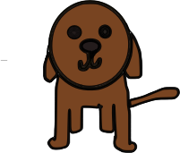 |  | This book belongs to:  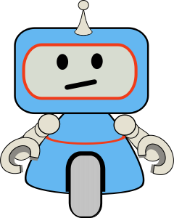 |  | This book belongs to:  
This book belongs to: |  | This book belongs to: |  | This book belongs to:
This book belongs to: |  | This book belongs to: |  | This book belongs to:
This book belongs to: |  | This book belongs to: |  | This book belongs to:
This book belongs to: |  | This book belongs to: |  | This book belongs to:
This book belongs to: |  | This book belongs to: |  | This book belongs to:
This book belongs to: |  | This book belongs to: |  | This book belongs to:
This book belongs to: |  | This book belongs to: |  | This book belongs to:
This book belongs to: |  | This book belongs to: |  | This book belongs to:
This book belongs to: |  | This book belongs to: |  | This book belongs to:
This book belongs to: |  | This book belongs to: |  | This book belongs to:
This book belongs to: |  | This book belongs to: |  | This book belongs to:
This book belongs to: |  | This book belongs to: |  | This book belongs to:
This book belongs to: |  | This book belongs to: |  | This book belongs to:
This book belongs to: |  | This book belongs to: |  | This book belongs to:
This book belongs to: |  | This book belongs to: |  | This book belongs to:
This book belongs to: |  | This book belongs to: |  | This book belongs to:
This book belongs to: |  | This book belongs to: |  | This book belongs to:
This book belongs to: |  | This book belongs to: |  | This book belongs to:
This book belongs to: |  | This book belongs to: |  | This book belongs to:

